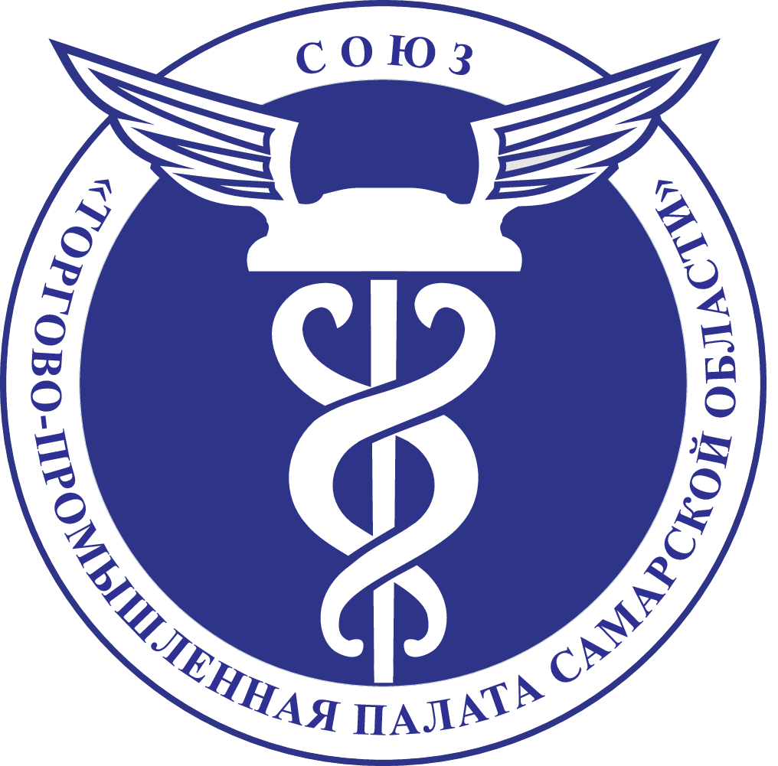

Programme of the Serbian session of the
Second International Online Forum R2R (Region2Region)
Serbian time (Samara’s time is +2 hours)

Time | Topic | Speaker
11:00 | Welcoming speech | Valery Fomichev, President of the Chamber of Commerce and Industry of the Samara region
11:10 | Welcoming speech | Boško Vučurević, President of the Chamber of Commerce and Industry of Vojvodina
11:20 | Welcoming speech | Andrej Hripunov,  Director of Trade Representative Office of Russia in Serbia
11:30 | Ceremony of signing the Cooperation agreement
11:40 | Presentation of the Chamber of Commerce and Industry of Samara region | Nikolai Kazakov,  Chief specialist of the Foreign Department
11:50 | Presentation of Chamber of commerce and industry of Vojvodina and Vojvodina region | Zoran Trpovski,  Industry Association Secretary, Chamber of commerce and industry of Vojvodina
12:00 | Presentation of the investment potential of the Samara region | Ministry of Economic Development
12:10 | Economic trends in Autonomous Province of Vojvodina | Jelena Bjelanović, Secretary to the Cabinet, Chamber of commerce and industry of Vojvodina
12:20 | Digital and IT development and technologies | Dmitry Kamynin,  head of the Project Office for Digital Development
12:30 | Conclusion  Questions

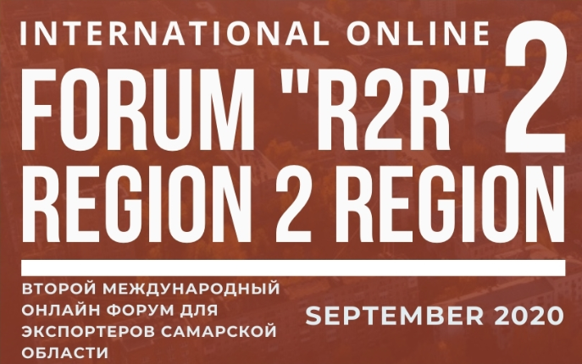

Link: HTTPS://ZOOM.US/J/5188278365

